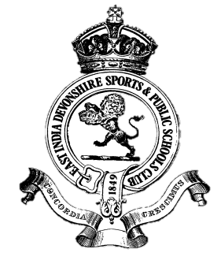
Club Blazers/ Waistcoat Order Form
Date:
Name:
Member Number:
Email/Mobile:

Please tick or circle you’re choice(s):
Sports Stripe Blazer ‘made to measure’ (£350)
Navy Blue Blazer ‘made to measure’ (£395)
Waistcoat in Club Stripe material (£160)

You’re Height in cm
You’re Weight in kg
You’re current jacket size

Using the Measurement guides on pages two and three attached please answer the following:

Body Measurement: Current Jacket measurement:
(Used for ordering blazers only)
1. Chest cm 1. Top Shoulder cm
2. Stomach cm 2. ½ Back cm
3. Waist cm 3. ½ Circumference cm
4. Seat cm 4. Jacket Length cm
5. Sleeve Length:
Left Sleeve cm
Right Sleeve cm

Please note posture observations to take in to account:

Posture: Stooping or Erect Shoulders: Square or Sloping

Choice: Single breasted or at an extra charge double breasted
Waistcoat with or without lapel
Linings navy blue or a choice available

Eddie will achieve the best fit possible with the measurements given.
There is a fitting charge of £40 if you wish to see Eddie in person.

Email this form to Eddie the tailor at eddieleebespoke@gmail.com
East India Club in the subject line
June 17

