Dogged Vintage Sydney-Hobart Racer Wins EIC RTI Trophy

As reported by Dr Sam Auty to the East India Club Yacht Squadron Laying Up Supper

Honorary Vice-Admiral, Commodore, Flag Officers, Your Excellency, Ladies and Gentlemen,

Now hear this!

I am the Herald for the East India Club Yacht Squadron Round the Island Trophy and now bring you news of my first-hand witness evidence of the race:

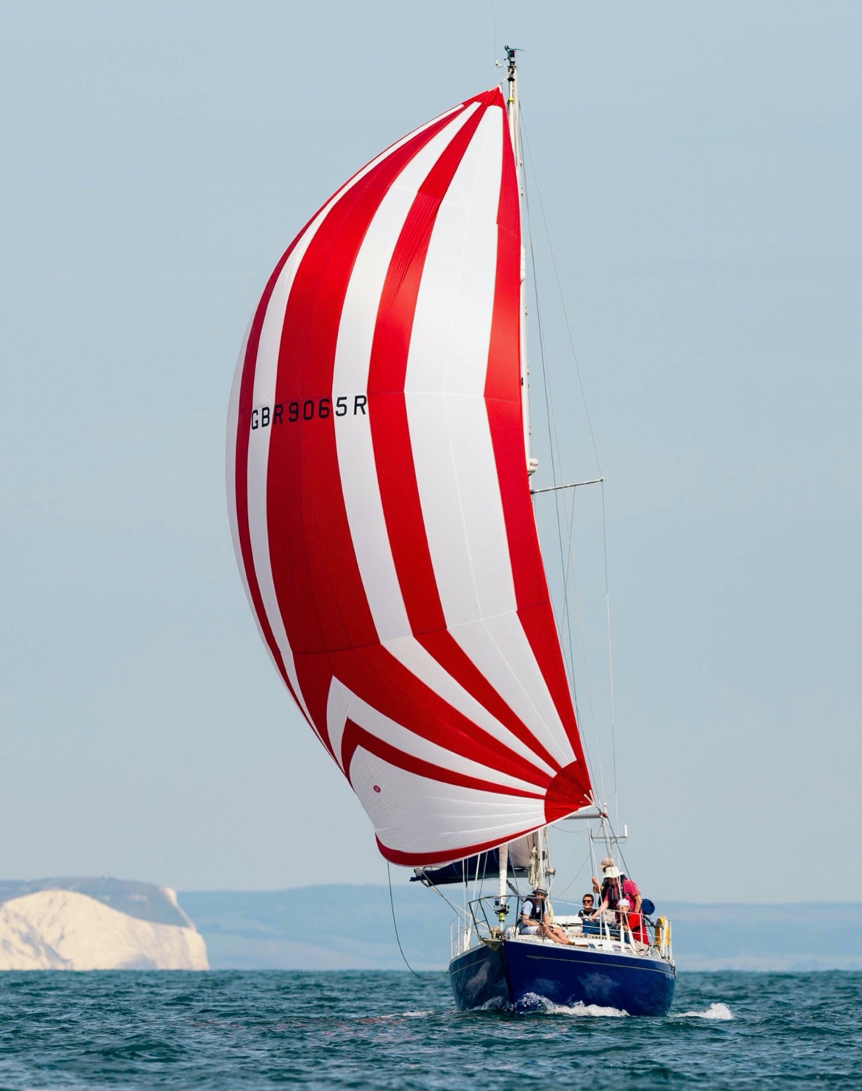
The Commodore's crew, at full power on Eagle, wearing the “Arsenal strip”
The Rustler Thirty Six Eagle’s hearty crew for Round the Island, a race with 1200 yachts assembled at Bucklers Hard at 0100 on the date of race, with myself at Bow, Jeff at Mast, Naomi at Pit, Ella at Trimmer-grinder, Nick on Mainsheet and the Commodore as Driver.

With the burgee fluttering at the starboard spreader, our start was under a pleasant Force 3 beam reach down from Cowes to the West. The Commodore’s attention to weight reduction prior to embarking turned out to be so fanatical that the asymmetric, much needed in the dropping Force 2 with a true wind angle of 80 degrees at Newtown, had been left behind at Bucklers Hard: I am bound by honour still to report the Commodore for this to the Vice Commodore as a Captain’s Socks duffer citation. His unusual sail provisioning meant that the Rustler 36 Border Riever, soon the leading Rustler 36, pulled two cables ahead of Eagle by Newtown.

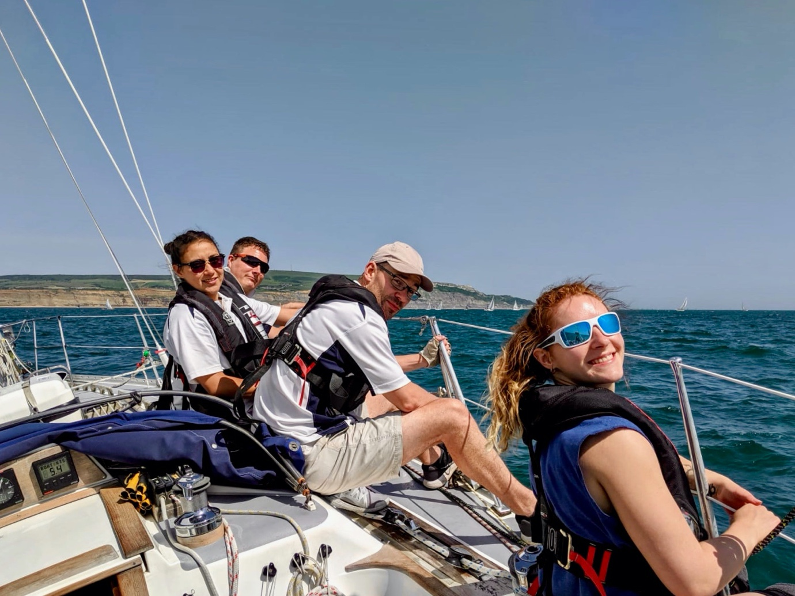
Eagle's crew on the rail, approaching St Catherine’s' Point
I can report though that while the Commodore zealously also offloaded 250 kg of fresh water among nearly 600 kg of stores offloaded prior to the race, (850 kg if one includes two extra and non very keen crew members left ashore) Eagle nevertheless raced within the esprit de corps of the East India, with her normal stores of East India Club gunpowder-proof Home on Furlough gin and Pusser’s black label gunpowder-proof rum aboard - and with a case of East India Club champagne in reserve down in the hold.

At Newtown, upon a wind shift, we were able to gybe onto starboard and raise our "Arsenal strip" symmetric spinnaker, much larger than Border Riever’s asymmetric. We aimed straight at Hurst, trotting along well and making ourselves extremely unpopular with virtually all of the rest of the fleet who were on port and aiming for Sconce.

After performing a text-book dip-pole gybe off the castle at Hurst onto port, we were three cables ahead of Border Riever; however, we became becalmed for twenty minutes before picking up an uncharacteristically useful puff down from Totland and Alum Bay to the Needles as hundreds of yachts that had started before us were becalmed and swept up to two miles too far west by the current. We never saw Border Riever again after the Needles, which the Commodore rounded just outside the Varvassi wreck’s engine and boiler rooms, and were clearly the leading Rustler Thirty Six throughout the rest of the race.

With neat tacking close inshore on the southern side of the island in order to minimise the foul tide, we made our way steadily up the fleet in a wind rising up eventually off St Catherine's to a glorious Force 7 Yachtsman's Gale with wall-to-wall blue skies above. With one reef taken in, Eagle with her heavy long keel leant over splendidly and began to smash the opposition all around us.

Tacking smartly at Dunnose Point, we were suddenly faced with almost no wind and a frightful chop in the overfalls and whirlpools off the point.

Floating on for two hours with the current and waiting with limited way and steerability for a wind that was not to come, we engaged in nautical yarn spinning and raucous shanty singing.

At 1830 the vote was taken to retire: there was no hope of finishing by the cut-off. The colours were raised at the stern to retire from racing and Eagle’s brave crew returned safely to land at 2200.

Elsewhere in the East India fleet, Alex van Ingen and his crew on the big 11-tonne Catalac cat Sea Spice suffered an even larger Friday-night plundering of their stores of East India Club house champagne and claret, accompanied by Fortnum & Mason coffee and chocolates and Paxton & Whitfield cheeses than usual: their hangovers while anchored in Osborne Bay were so intense this year on race day that they elected not to start but snooze on at anchor.

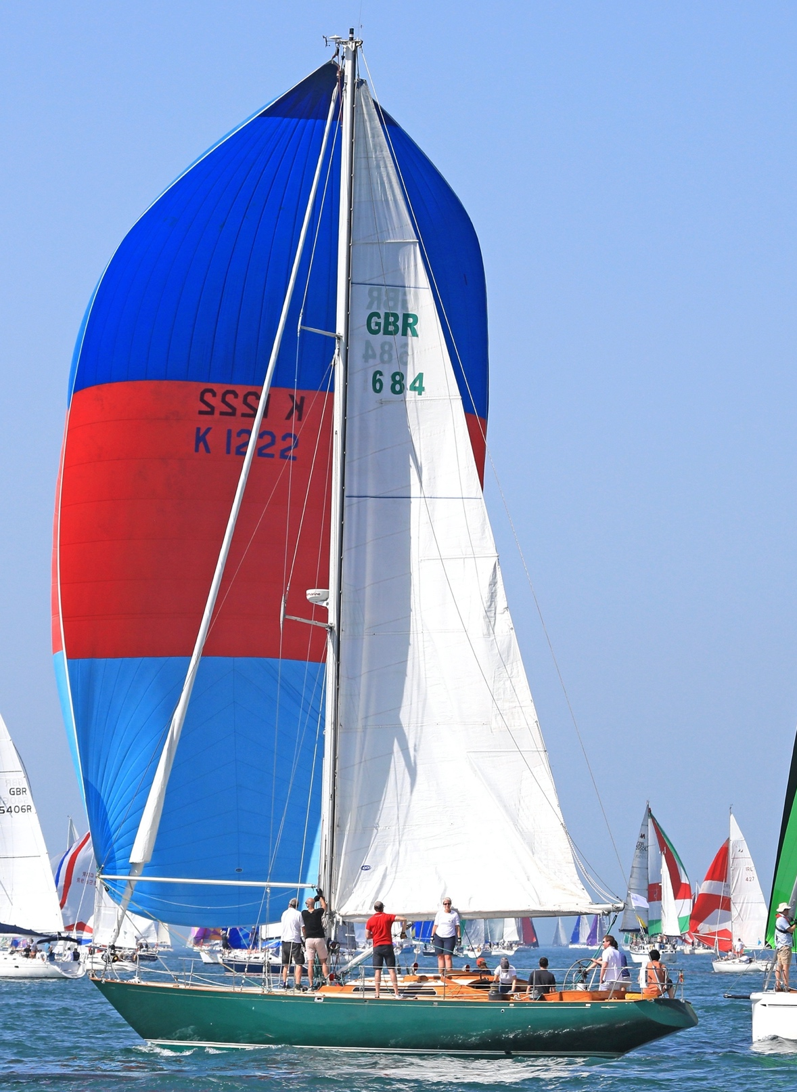
Andrew Tseng on his Admiral's Cup and Sydney-Hobart racer Quailo on the way to winning
I must commend to this Company tonight Andrew Tseng and his crew on the tremendous Admiral’s Cup and Sydney-to-Hobart Nicholson Fifty Five Quailo. They were seen flying one of the largest symmetric kites in the race off Hurst to great effect and timed their rounding of the Needles to perfection. Their handling of such an impressive and heavy offshore racer in the light airs was highly skilful and dedicated. They refused to give up as hundreds of yachts including many much faster J/88 and J/70 sports boats retired all around them.

They raced on hard and tenaciously into the dusk and then into dark, crawling valiantly yet steadfastly past Ryde and then Osborne towards Cowes. Andrew and his crew on Quailo made it home over the line at Cowes in most tenacious fashion, crossing the finishing line just before the 2230 race cutoff.

As your Herald and witness, I do therefore hereby declare the deserved and gallant winner of the 2019 East India Round the Island Trophy to be Andrew Tseng on his Nicholson Fifty Five, Quailo.

