Stylish SW3 Artists Storm Newman VC Trophy

As reported by Sub Lieutentant Lachlan Mulholland RN, Rear Commodore Racing, to the East India Club Yacht Squadron Laying Up Supper

Honorary Vice-Admiral, Commodore, Fellow Flag Officers, Your Excellency, Ladies and Gentlemen, Fellow Royal Navy Officers:

Now hear this!

I, Rear Commodore Racing of the East India Yacht Club Yacht Squadron and Herald for the Newman VC Trophy bring you my witness of the annual EAST INDIA CLUB YACHT SQUADRON NEWMAN VC TROPHY REGATTA held on the fourteenth day of September 2019 at Seaview on the Isle of Wight.

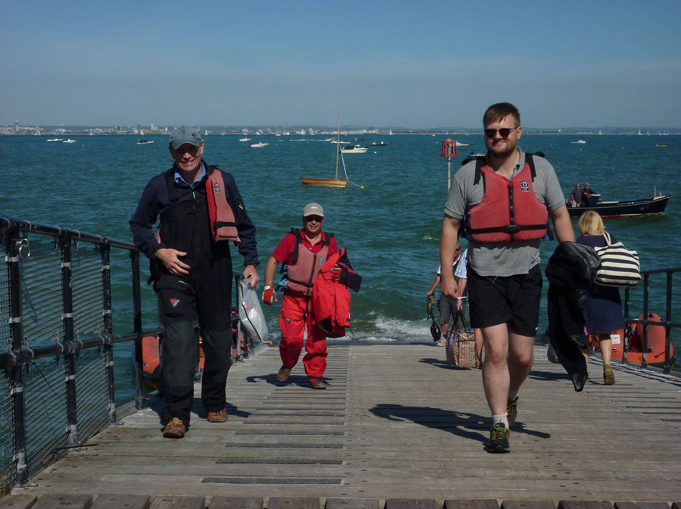
The East India & St Nazaire crew at Seaview: Commodore Henderson RN (St Nazaire Society), Vice Commodore Rose & Rear Commodore Racing Sub Lieutenant Mulholland RN
The East India crews assembled onboard the Commodore’s yacht Eagle on the night before the regatta at Hamble marina, where an early tactical decision was made to immediately retire to the bar at the Royal Southern Yacht Club to properly plan for the day of racing ahead. Once fully wetted it was almost as quickly decided that the crew should be properly victualed as well and within only a few more rounds the traditional food of the East India Club, a curry, was decided upon. It was in this manner that the crews of the East India Club fully prepared themselves, managing to arrive back onboard Eagle in time to have a full watch of sleep before setting sail in the morning watch.
A pleasant power sail across the Solent completed the East India’s training and meant that we arrived off Seaview in time to welcome Commodore Henderson RN of the St Nazaire Society onboard for bacon sandwiches and for the joint East India/St Nazaire crew to meet and discuss the days actuals.

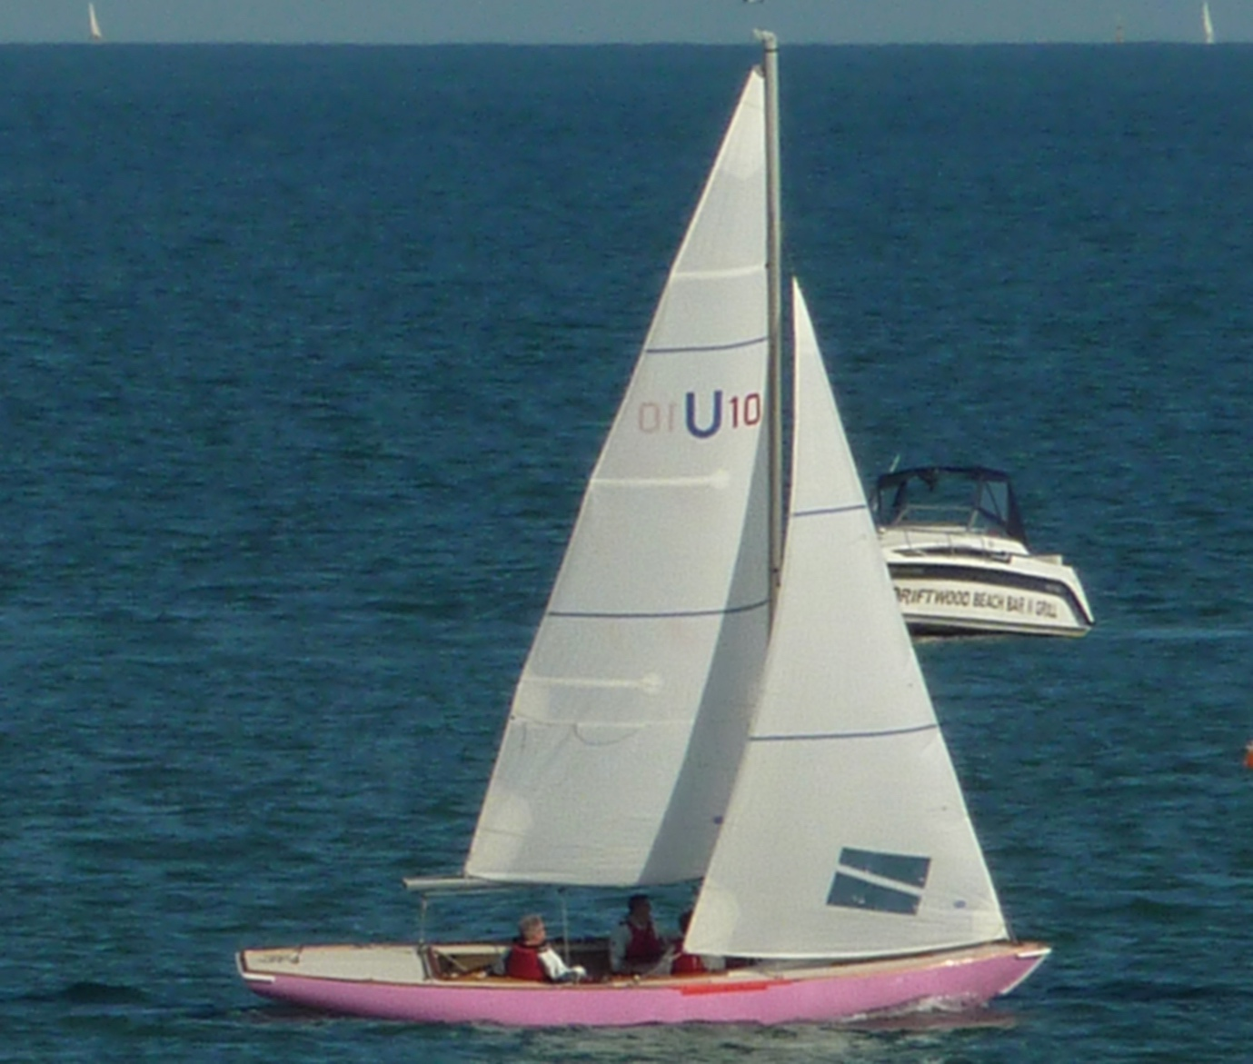
The Commodore going upwind, with J7 Billy Roberts and Jeff Christie aboard
The winds being light and Northerly and with at least half a knot of tide from the South East would mean a difficult start to the forenoon but with slack water expected before midday the conditions should slowly improve; but with a cloudless sky and a high of 22 degrees a pleasant day of sailing lay ahead.

Once all four of this year crews; comprising the aforementioned East India and St Nazaire along with the Chelsea Arts and Little Ships Clubs had gathered inside the Sea View Yacht Club an explanation, needed by some, of the racing rules and signals to be used was given followed by the all-important selection of the mermaids:

The joint EIC & St Nazaire choosing Cynthia in red,
The Little Ship Club on Zara in blue,
The EIC on Adestra in pink
And The Chelsea Arts choosing Miranda, in Black, this being a foretelling of the shadow that they would soon be putting the other crews under for the rest of the day.

The crews then set out to embark on their respective mermaids and began rigging them. This proved to be no simple task given the number of sheets, halliards and up and down hauls present on the un-familiar boats, that it was even suggested between crews that spinnakers might not be used in the first race; however, once under sail all crews proved their competence as they began making their way towards the start line and to await the first course to be announced. A windward/leeward course, a trait that would be familiar of all the races of the day, led to much discussion over trying to identify which of the several dozen buoys off Sea View was the race that we needed. After a good racing start by all, the Little Ship Club struck out an early lead helping to confirm the race marks, managing to retain this early lead throughout the race and claim the first victory, a feat that they did not manage to repeat in the second race.

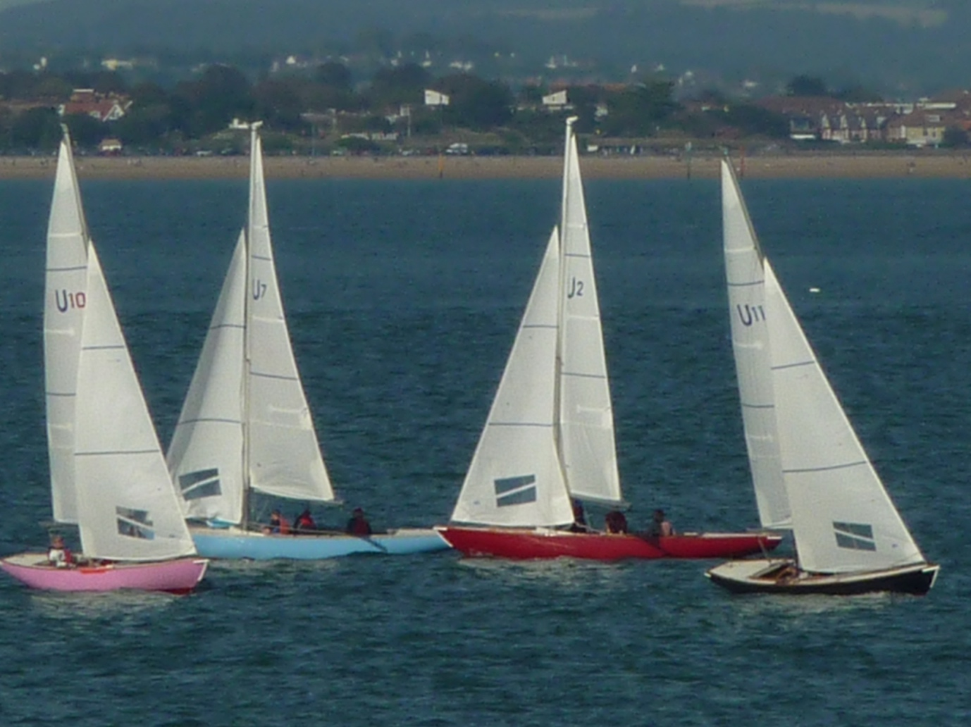
A busy leeward mark during the Newman VC Trophy
The second race was taken by the Chelsea Arts Club beginning to show the skill that they would display for much of the rest of the day.

The East India crew had trouble in the third race struggling to properly set their spinnaker for the run across the finish line and leading to them having to withdraw.

A final race before lunch saw a glimmer of hope as the Little Ship crew managed to sail through to a second win and putting them in the lead for the time begin, and closely followed by the East India who seemed to have sorted their spinnaker problems, and so it was with the tide on the turn and the wind dropping it was time to head in for lunch.

As I am sure all who were present will attest the kitchens at Sea View were well provisioned, provided a good spread and a fine lunch was enjoyed, including a few trips from the terrace to the bar and back!

After being freshly victualled and heading back out with renewed vigour but with the wind still dropping and the current picking up now from the North there was some doubt about how long the sailing would last in the afternoon: the light winds and strong tide would be a true test of sailing ability.

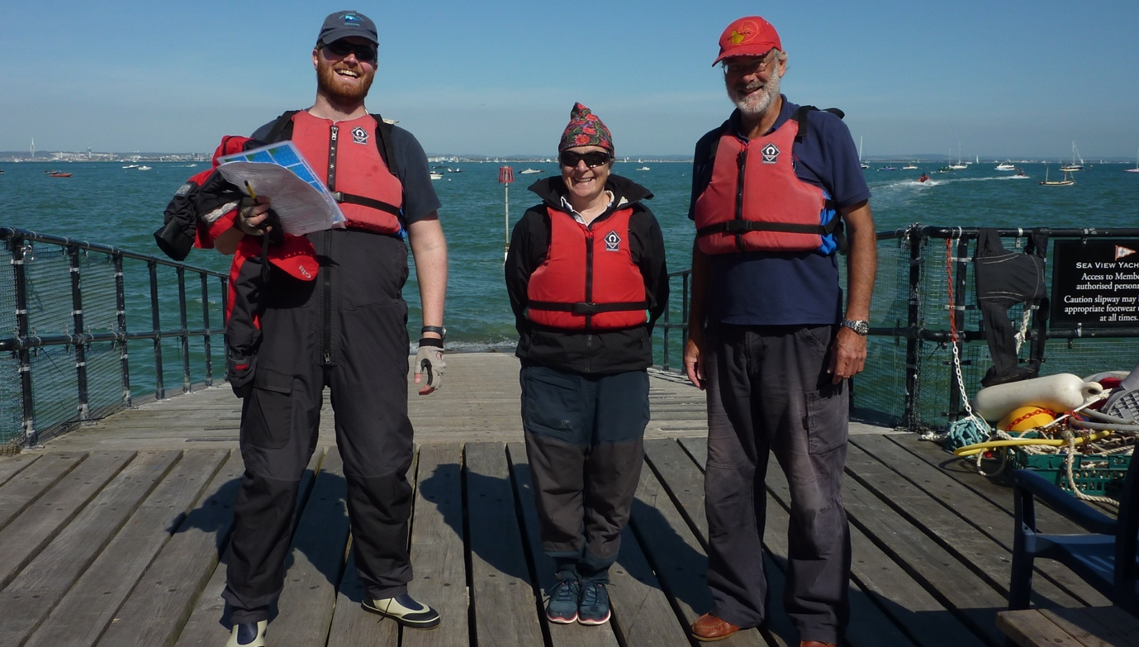
The skilful Little Ship Club crew
I have to say that it was a fait accompli with the Chelsea Arts easily winning both races that were managed before the wind finally dropped. This might been due to them taking a tactical chance and heading inshore and taking bold decisions on when it was most opportune to tack for windward mark much, much more accurately than the other boats.

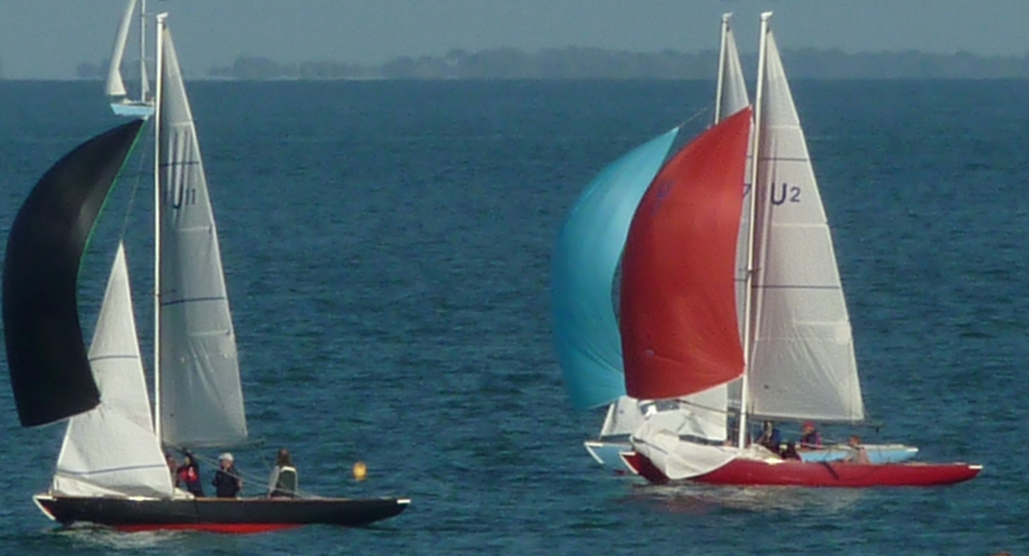
The Chelsea Arts Club, leading downwind
It had however been raise over lunch that the Chelsea Arts may have had somewhat of an advantage over some of the other crews as it had come to light they have in fact be known to practise and were also displaying a high level of competency, something that I know that I have never been accused off.

These two wins however ensured victory for the Chelsea Arts though closely in their wake was the Little Ship Club.

It had been a very fair day’s sailing, if perhaps a little too fair. And so all that remain was for Eagles crew to embark, weigh anchor, and set sail for Hamble and onto Beaulieu. And to await the inevitable keel hauling that I expected for my own dismal performance.

I can therefore report Commodore successful completion of fourth EAST INDIA CLUB YACHT SQUADRON NEWMAN VC TROPHY REGATTA and…

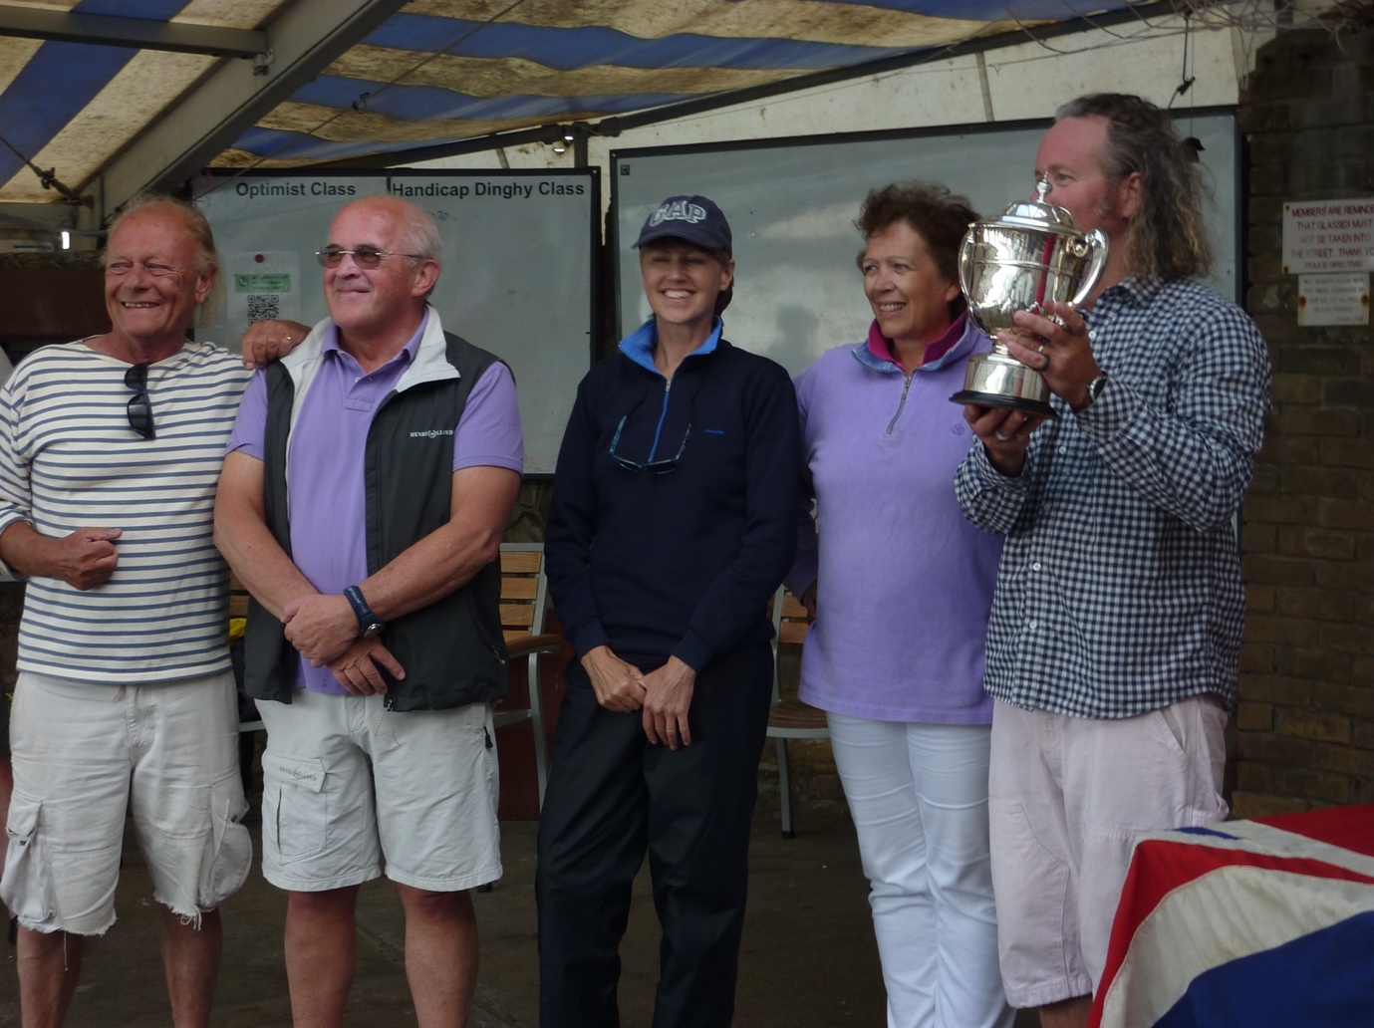
The Chelsea Arts club - deserved tr0phy winners
As Herald and witness I do therefore declare that this year’s most deserved winners of the Newman VC Trophy to be the Chelsea Arts Club and I ask Commodore Henderson to present the trophy to them.

